Procedures to customize voice commands

- Register in this voice platform https://smartpi.cn/#/register
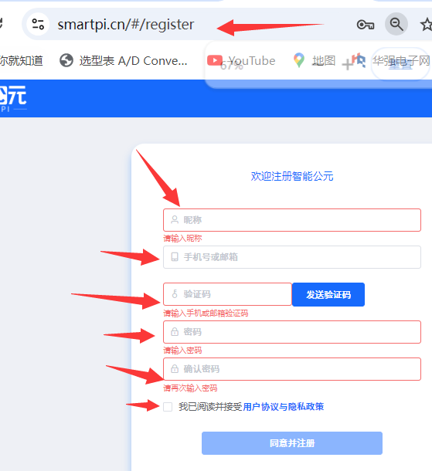
- Login and access the product catalog, select input products
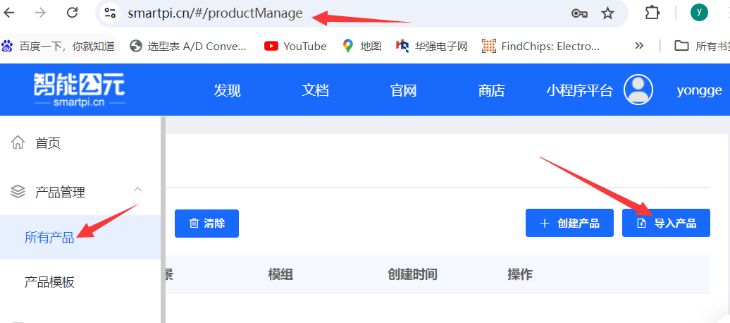
- Input the file
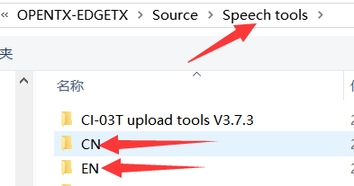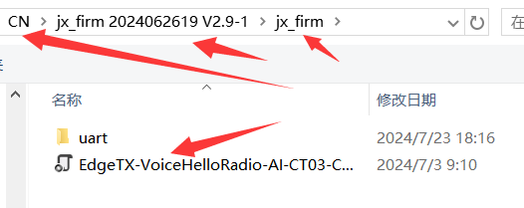
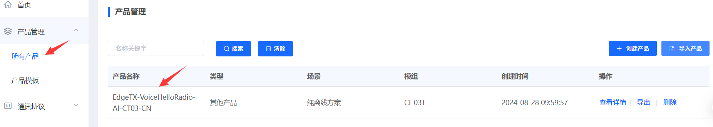
- Check the details
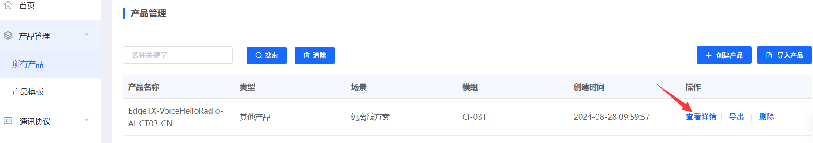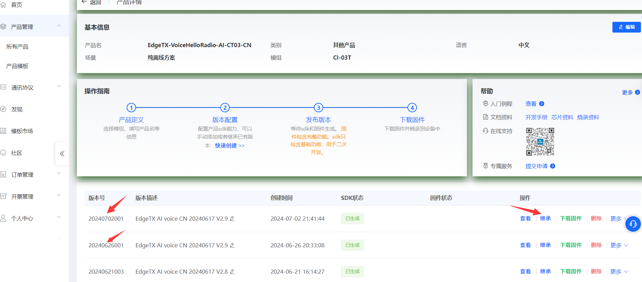
- Select “inheret”, input the voice name at “1”, and edit the current voice at “2”
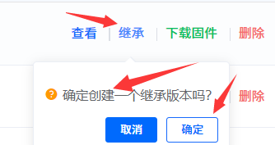
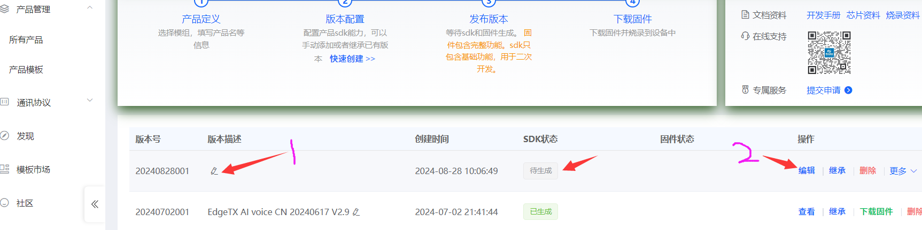
- Change the wakeup command. Note: try simple change first, and then complicated ones. You can return to the older version if any problems.
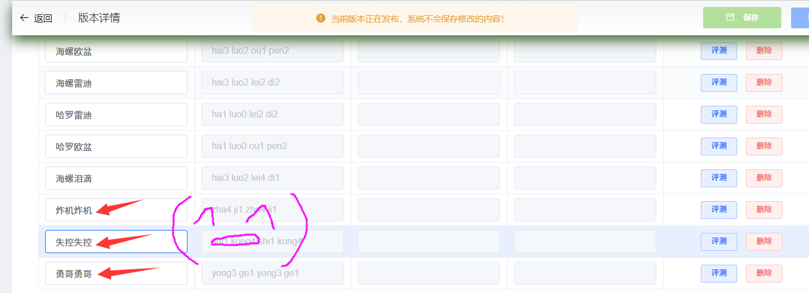

- Change the action command. Note: try simple change first, and then complicated ones. You can return to the older version if any problems.
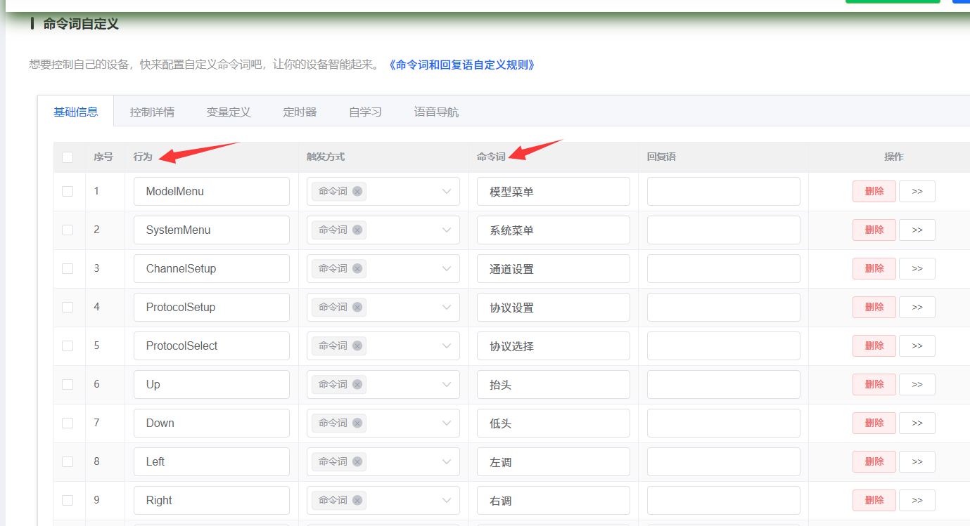
- Note: the above changes are based on current commands. If you want to add extra commands, you will need to modify the EDGETX code to be supported by software.
- Release the version, 1 to save, 2 to publish. Releasing is actually a cloud compilation of the instructions you modify by the voice platform. The Chinese compilation time is very long, and the English compilation time is relatively short, both taking a few minutes to tens of minutes. Please be patient because there are many people queuing for compilation (^ _ ^)

Actually, you don't need to rush. After completion, your phone will receive a prompt message:
【智能公元】The SDK for your customized [EdgeTX VoiceHelloRadio-AI-CT03-CN] has been generated and can be viewed and downloaded from the website. This voice company is still very considerate
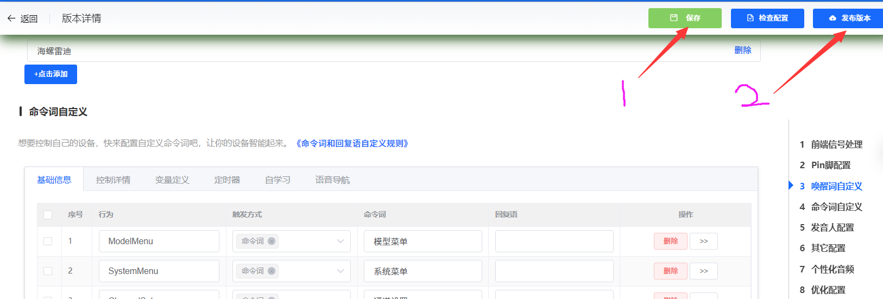
- Compilation
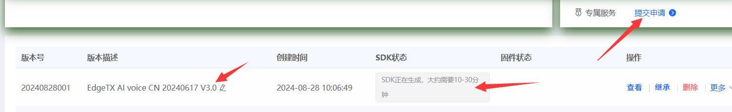
Download firmware
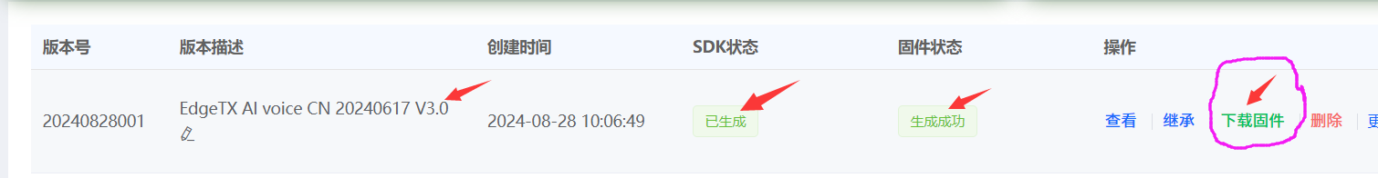
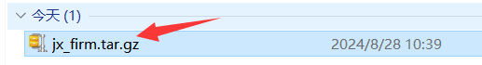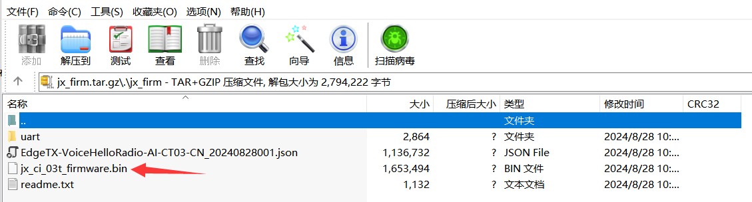
- Using programming tools and methods, flash voice files to the radio, and you can have fun. Dedicated to our RC friends who love to tinker (^ _ ^) (^ _ ^) (^ _ ^)
- Finally, if you have funny and successfully tested voice commands, don't forget to share the *. json file

HelloRadioSky QQ技术交流群：83162463 微信群技术交流群：
https://www.helloradiosky.com

